UNITED STATES
SECURITIES AND EXCHANGE COMMISSION
Washington, D.C. 20549
FORM 8-K
CURRENT REPORT
Pursuant to Section 13 or 15(d) of the
Securities Exchange Act of 1934
Date of report (date of earliest event reported): May 7, 2026
DRILLING TOOLS INTERNATIONAL CORPORATION
(Exact name of registrant as specified in its charter)

Delaware |  | 001-41103 |  | 87-2488708
(State or other  jurisdiction of incorporation) |  | (Commission File Number) |  | (I.R.S. Employer  Identification No.)

10370 Richmond Ave., Suite 1000  Houston, Texas |  | 77042
(Address of principal executive offices) |  | (Zip Code)
Registrant’s telephone number, including area code: (832) 742-8500
Check the appropriate box below if the Form 8-K filing is intended to simultaneously satisfy the filing obligation of the registrant under any of the following provisions:

☐ | Written communications pursuant to Rule 425 under the Securities Act (17 CFR 230.425)
☐ | Soliciting material pursuant to Rule 14a-12 under the Exchange Act (17 CFR 240.14a-12)
☐ | Pre-commencement communications pursuant to Rule 14d-2(b) under the Exchange Act (17 CFR 240.14d-2(b))
☐ | Pre-commencement communications pursuant to Rule 13e-4(c) under the Exchange Act (17 CFR 240.13e-4(c))
Securities registered pursuant to Section 12(b) of the Act:

Title of each class: |  | Trading Symbol(s) |  | Name of each exchange on which registered:
Common stock, par value $0.0001 per share |  | DTI |  | The Nasdaq Stock Market LLC
Indicate by check mark whether the registrant is an emerging growth company as defined in Rule 405 of the Securities Act of 1933 (§230.405 of this chapter) or Rule 12b-2 of the Securities Exchange Act of 1934 (§240.12b-2 of this chapter).
Emerging growth company ☒
If an emerging growth company, indicate by check mark if the registrant has elected not to use the extended transition period for complying with any new or revised financial accounting standards provided pursuant to Section 13(a) of the Exchange Act. ☐

Item 7.01. Regulation FD Disclosure.
Attached as Exhibit 99.1 to this Current Report on Form 8-K is an investor presentation that Drilling Tools International Corporation (the “Company”) plans to use for investor relations and other purposes.
The information in this report and the exhibits attached hereto shall not be deemed to be “filed” for purposes of the Securities Exchange Act of 1934 (the “Exchange Act”) or otherwise subject to the liabilities of that section, not shall it be deemed incorporated by reference in any filing under the Securities Act of 1933, as amended, or the Exchange Act, regardless of any general incorporation language in such filing.
Item 9.01. Financial Statements and Exhibits
(d) Exhibits

99.1 |  | Investor Presentation (Summer 2026)
104 |  | Cover Page Interactive Data File (embedded within the Inline XBRL document).

SIGNATURE
Pursuant to the requirements of the Securities Exchange Act of 1934, the Registrant has duly caused this report to be signed on its behalf by the undersigned hereunto duly authorized.
Dated: May 7, 2026

DRILLING TOOLS INTERNATIONAL CORPORATION
By: |  | /s/ David R. Johnson
 |  | David R. Johnson
 |  | Chief Financial Officer
 |  | (Principal Financial and Accounting Officer)
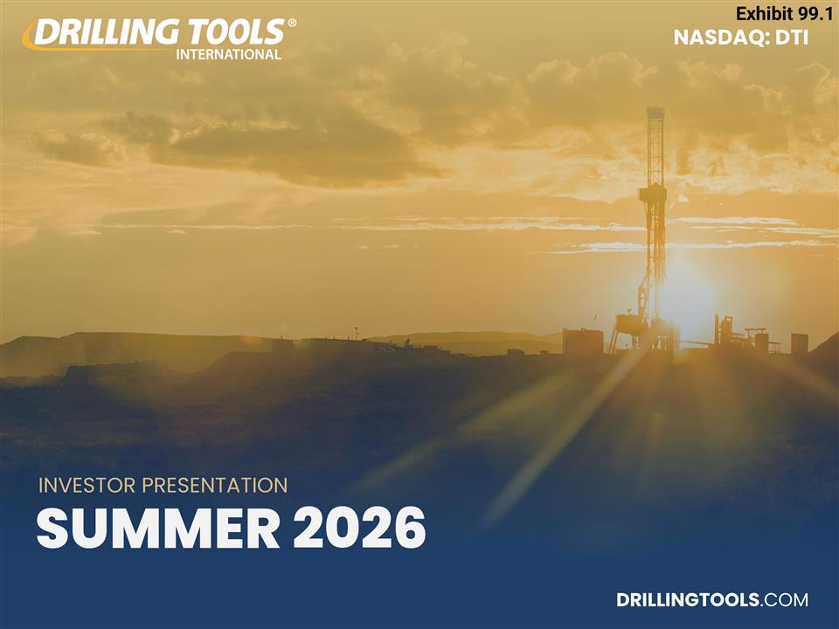
INVESTOR PRESENTATION SUMMER 2026 DRILLINGTOOLS.COM NASDAQ: DTI Exhibit 99.1

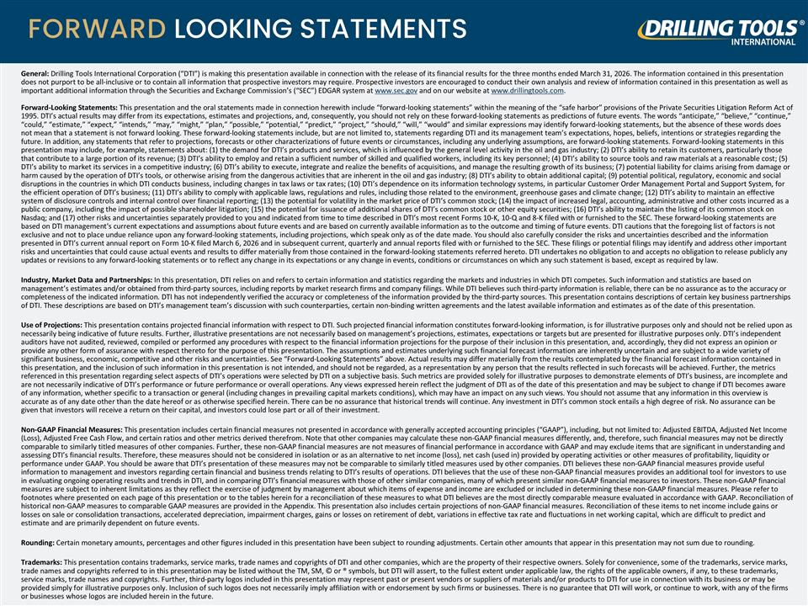
FORWARD LOOKING STATEMENTS General: Drilling Tools International Corporation (“DTI”) is making this presentation available in connection with the release of its financial results for the three months ended March 31, 2026. The information contained in this presentation does not purport to be all-inclusive or to contain all information that prospective investors may require. Prospective investors are encouraged to conduct their own analysis and review of information contained in this presentation as well as important additional information through the Securities and Exchange Commission’s (“SEC”) EDGAR system at www.sec.gov and on our website at www.drillingtools.com. Forward-Looking Statements: This presentation and the oral statements made in connection herewith include “forward-looking statements” within the meaning of the “safe harbor” provisions of the Private Securities Litigation Reform Act of 1995. DTI’s actual results may differ from its expectations, estimates and projections, and, consequently, you should not rely on these forward-looking statements as predictions of future events. The words “anticipate,” “believe,” “continue,” “could,” “estimate,” “expect,” “intends,” “may,” “might,” “plan,” “possible,” “potential,” “predict,” “project,” “should,” “will,” “would” and similar expressions may identify forward-looking statements, but the absence of these words does not mean that a statement is not forward looking. These forward-looking statements include, but are not limited to, statements regarding DTI and its management team’s expectations, hopes, beliefs, intentions or strategies regarding the future. In addition, any statements that refer to projections, forecasts or other characterizations of future events or circumstances, including any underlying assumptions, are forward-looking statements. Forward-looking statements in this presentation may include, for example, statements about: (1) the demand for DTI’s products and services, which is influenced by the general level activity in the oil and gas industry; (2) DTI’s ability to retain its customers, particularly those that contribute to a large portion of its revenue; (3) DTI’s ability to employ and retain a sufficient number of skilled and qualified workers, including its key personnel; (4) DTI’s ability to source tools and raw materials at a reasonable cost; (5) DTI’s ability to market its services in a competitive industry; (6) DTI’s ability to execute, integrate and realize the benefits of acquisitions, and manage the resulting growth of its business; (7) potential liability for claims arising from damage or harm caused by the operation of DTI’s tools, or otherwise arising from the dangerous activities that are inherent in the oil and gas industry; (8) DTI’s ability to obtain additional capital; (9) potential political, regulatory, economic and social disruptions in the countries in which DTI conducts business, including changes in tax laws or tax rates; (10) DTI’s dependence on its information technology systems, in particular Customer Order Management Portal and Support System, for the efficient operation of DTI’s business; (11) DTI’s ability to comply with applicable laws, regulations and rules, including those related to the environment, greenhouse gases and climate change; (12) DTI’s ability to maintain an effective system of disclosure controls and internal control over financial reporting; (13) the potential for volatility in the market price of DTI’s common stock; (14) the impact of increased legal, accounting, administrative and other costs incurred as a public company, including the impact of possible shareholder litigation; (15) the potential for issuance of additional shares of DTI’s common stock or other equity securities; (16) DTI’s ability to maintain the listing of its common stock on Nasdaq; and (17) other risks and uncertainties separately provided to you and indicated from time to time described in DTI’s most recent Forms 10-K, 10-Q and 8-K filed with or furnished to the SEC. These forward-looking statements are based on DTI management's current expectations and assumptions about future events and are based on currently available information as to the outcome and timing of future events. DTI cautions that the foregoing list of factors is not exclusive and not to place undue reliance upon any forward-looking statements, including projections, which speak only as of the date made. You should also carefully consider the risks and uncertainties described and the information presented in DTI’s current annual report on Form 10-K filed March 6, 2026 and in subsequent current, quarterly and annual reports filed with or furnished to the SEC. These filings or potential filings may identify and address other important risks and uncertainties that could cause actual events and results to differ materially from those contained in the forward-looking statements referred hereto. DTI undertakes no obligation to and accepts no obligation to release publicly any updates or revisions to any forward-looking statements or to reflect any change in its expectations or any change in events, conditions or circumstances on which any such statement is based, except as required by law. Industry, Market Data and Partnerships: In this presentation, DTI relies on and refers to certain information and statistics regarding the markets and industries in which DTI competes. Such information and statistics are based on management’s estimates and/or obtained from third-party sources, including reports by market research firms and company filings. While DTI believes such third-party information is reliable, there can be no assurance as to the accuracy or completeness of the indicated information. DTI has not independently verified the accuracy or completeness of the information provided by the third-party sources. This presentation contains descriptions of certain key business partnerships of DTI. These descriptions are based on DTI’s management team’s discussion with such counterparties, certain non-binding written agreements and the latest available information and estimates as of the date of this presentation. Use of Projections: This presentation contains projected financial information with respect to DTI. Such projected financial information constitutes forward-looking information, is for illustrative purposes only and should not be relied upon as necessarily being indicative of future results. Further, illustrative presentations are not necessarily based on management’s projections, estimates, expectations or targets but are presented for illustrative purposes only. DTI’s independent auditors have not audited, reviewed, compiled or performed any procedures with respect to the financial information projections for the purpose of their inclusion in this presentation, and, accordingly, they did not express an opinion or provide any other form of assurance with respect thereto for the purpose of this presentation. The assumptions and estimates underlying such financial forecast information are inherently uncertain and are subject to a wide variety of significant business, economic, competitive and other risks and uncertainties. See “Forward-Looking Statements” above. Actual results may differ materially from the results contemplated by the financial forecast information contained in this presentation, and the inclusion of such information in this presentation is not intended, and should not be regarded, as a representation by any person that the results reflected in such forecasts will be achieved. Further, the metrics referenced in this presentation regarding select aspects of DTI’s operations were selected by DTI on a subjective basis. Such metrics are provided solely for illustrative purposes to demonstrate elements of DTI’s business, are incomplete and are not necessarily indicative of DTI’s performance or future performance or overall operations. Any views expressed herein reflect the judgment of DTI as of the date of this presentation and may be subject to change if DTI becomes aware of any information, whether specific to a transaction or general (including changes in prevailing capital markets conditions), which may have an impact on any such views. You should not assume that any information in this overview is accurate as of any date other than the date hereof or as otherwise specified herein. There can be no assurance that historical trends will continue. Any investment in DTI’s common stock entails a high degree of risk. No assurance can be given that investors will receive a return on their capital, and investors could lose part or all of their investment. Non-GAAP Financial Measures: This presentation includes certain financial measures not presented in accordance with generally accepted accounting principles (“GAAP”), including, but not limited to: Adjusted EBITDA, Adjusted Net Income (Loss), Adjusted Free Cash Flow, and certain ratios and other metrics derived therefrom. Note that other companies may calculate these non-GAAP financial measures differently, and, therefore, such financial measures may not be directly comparable to similarly titled measures of other companies. Further, these non-GAAP financial measures are not measures of financial performance in accordance with GAAP and may exclude items that are significant in understanding and assessing DTI’s financial results. Therefore, these measures should not be considered in isolation or as an alternative to net income (loss), net cash (used in) provided by operating activities or other measures of profitability, liquidity or performance under GAAP. You should be aware that DTI’s presentation of these measures may not be comparable to similarly titled measures used by other companies. DTI believes these non-GAAP financial measures provide useful information to management and investors regarding certain financial and business trends relating to DTI’s results of operations. DTI believes that the use of these non-GAAP financial measures provides an additional tool for investors to use in evaluating ongoing operating results and trends in DTI, and in comparing DTI’s financial measures with those of other similar companies, many of which present similar non-GAAP financial measures to investors. These non-GAAP financial measures are subject to inherent limitations as they reflect the exercise of judgment by management about which items of expense and income are excluded or included in determining these non-GAAP financial measures. Please refer to footnotes where presented on each page of this presentation or to the tables herein for a reconciliation of these measures to what DTI believes are the most directly comparable measure evaluated in accordance with GAAP. Reconciliation of historical non-GAAP measures to comparable GAAP measures are provided in the Appendix. This presentation also includes certain projections of non-GAAP financial measures. Reconciliation of these items to net income include gains or losses on sale or consolidation transactions, accelerated depreciation, impairment charges, gains or losses on retirement of debt, variations in effective tax rate and fluctuations in net working capital, which are difficult to predict and estimate and are primarily dependent on future events. Rounding: Certain monetary amounts, percentages and other figures included in this presentation have been subject to rounding adjustments. Certain other amounts that appear in this presentation may not sum due to rounding. Trademarks: This presentation contains trademarks, service marks, trade names and copyrights of DTI and other companies, which are the property of their respective owners. Solely for convenience, some of the trademarks, service marks, trade names and copyrights referred to in this presentation may be listed without the TM, SM, © or ® symbols, but DTI will assert, to the fullest extent under applicable law, the rights of the applicable owners, if any, to these trademarks, service marks, trade names and copyrights. Further, third-party logos included in this presentation may represent past or present vendors or suppliers of materials and/or products to DTI for use in connection with its business or may be provided simply for illustrative purposes only. Inclusion of such logos does not necessarily imply affiliation with or endorsement by such firms or businesses. There is no guarantee that DTI will work, or continue to work, with any of the firms or businesses whose logos are included herein in the future.

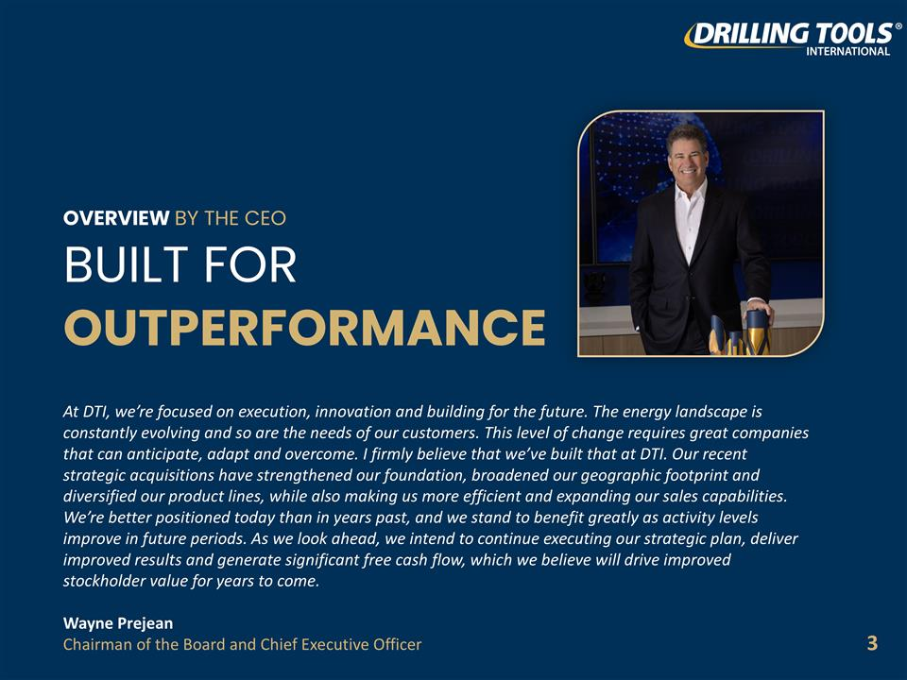
OVERVIEW BY THE CEO BUILT FOR OUTPERFORMANCE At DTI, we’re focused on execution, innovation and building for the future. The energy landscape is constantly evolving and so are the needs of our customers. This level of change requires great companies that can anticipate, adapt and overcome. I firmly believe that we’ve built that at DTI. Our recent strategic acquisitions have strengthened our foundation, broadened our geographic footprint and diversified our product lines, while also making us more efficient and expanding our sales capabilities. We’re better positioned today than in years past, and we stand to benefit greatly as activity levels improve in future periods. As we look ahead, we intend to continue executing our strategic plan, deliver improved results and generate significant free cash flow, which we believe will drive improved stockholder value for years to come. Wayne Prejean Chairman of the Board and Chief Executive Officer 3

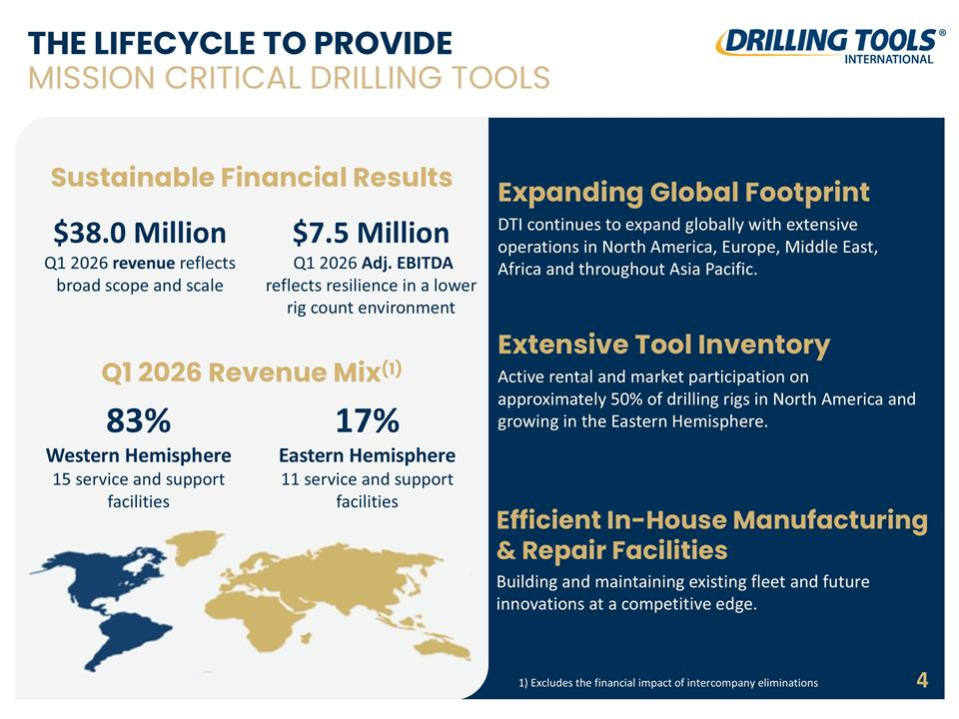
THE LIFECYCLE TO PROVIDE MISSION CRITICAL DRILLING TOOLS Extensive Tool Inventory Active rental and market participation on approximately 50% of drilling rigs in North America and growing in the Eastern Hemisphere. Efficient In-House Manufacturing & Repair Facilities Building and maintaining existing fleet and future innovations at a competitive edge. Expanding Global Footprint DTI continues to expand globally with extensive operations in North America, Europe, Middle East, Africa and throughout Asia Pacific. Sustainable Financial Results $38.0 Million Q1 2026 revenue reflects broad scope and scale $7.5 Million Q1 2026 Adj. EBITDA reflects resilience in a lower rig count environment Q1 2026 Revenue Mix(1) 83% Western Hemisphere 15 service and support facilities 17% Eastern Hemisphere 11 service and support facilities 4 1) Excludes the financial impact of intercompany eliminations

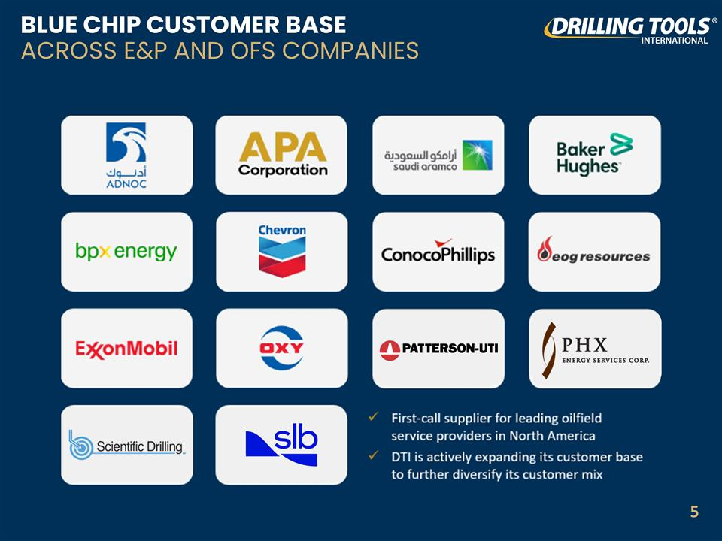
BLUE CHIP CUSTOMER BASE ACROSS E&P AND OFS COMPANIES 5

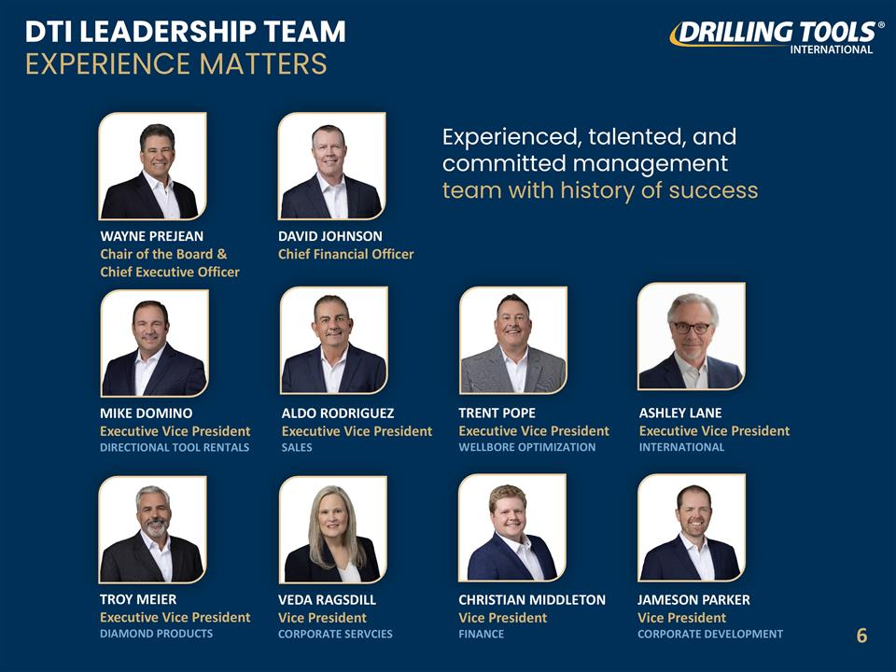
DTI LEADERSHIP TEAM EXPERIENCE MATTERS Experienced, talented, and committed management team with history of success ALDO RODRIGUEZ Executive Vice President SALES DAVID JOHNSON Chief Financial Officer MIKE DOMINO Executive Vice President DIRECTIONAL TOOL RENTALS WAYNE PREJEAN Chair of the Board & Chief Executive Officer TROY MEIER Executive Vice President DIAMOND PRODUCTS ASHLEY LANE Executive Vice President INTERNATIONAL VEDA RAGSDILL Vice President CORPORATE SERVCIES CHRISTIAN MIDDLETON Vice President FINANCE JAMESON PARKER Vice President CORPORATE DEVELOPMENT TRENT POPE Executive Vice President WELLBORE OPTIMIZATION 6

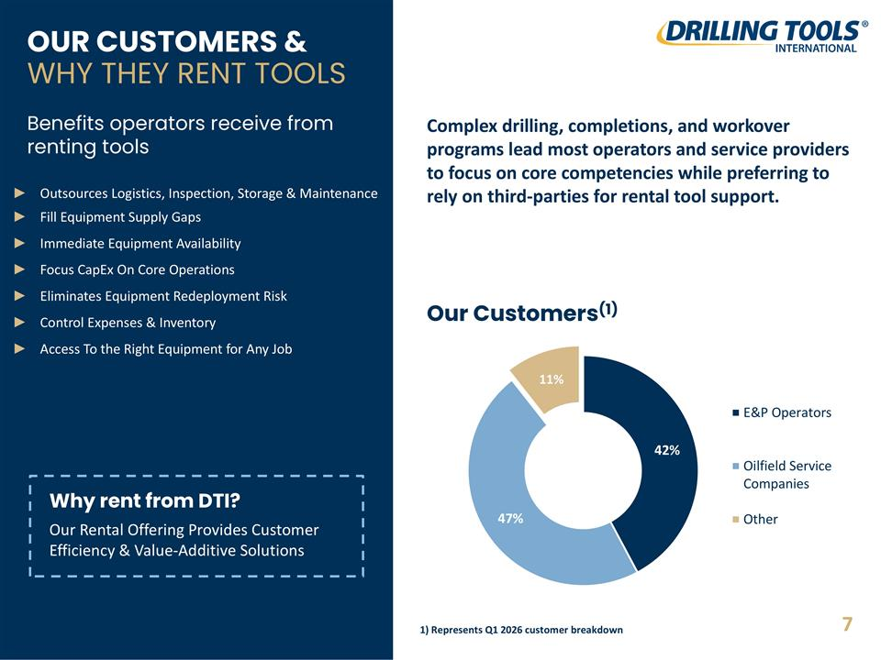
OUR CUSTOMERS & WHY THEY RENT TOOLS Outsources Logistics, Inspection, Storage & Maintenance Fill Equipment Supply Gaps Immediate Equipment Availability Focus CapEx On Core Operations Eliminates Equipment Redeployment Risk Control Expenses & Inventory Access To the Right Equipment for Any Job Benefits operators receive from renting tools Our Customers(1) Complex drilling, completions, and workover programs lead most operators and service providers to focus on core competencies while preferring to rely on third-parties for rental tool support. Why rent from DTI? Our Rental Offering Provides Customer Efficiency & Value-Additive Solutions 7 1) Represents Q1 2026 customer breakdown

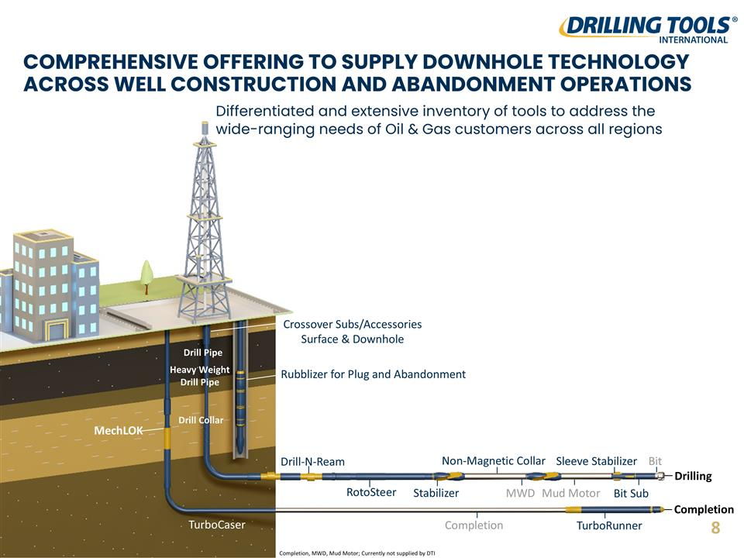
COMPREHENSIVE OFFERING TO SUPPLY DOWNHOLE TECHNOLOGY ACROSS WELL CONSTRUCTION AND ABANDONMENT OPERATIONS Differentiated and extensive inventory of tools to address the wide-ranging needs of Oil & Gas customers across all regions Heavy Weight Drill Pipe Stabilizer Drill-N-Ream RotoSteer Non-Magnetic Collar Drill Collar Bit Sub Rubblizer for Plug and Abandonment MechLOK TurboRunner MWD Crossover Subs/Accessories Surface & Downhole Bit Sleeve Stabilizer Drilling Drill Pipe Mud Motor Completion Completion TurboCaser Completion, MWD, Mud Motor; Currently not supplied by DTI 8

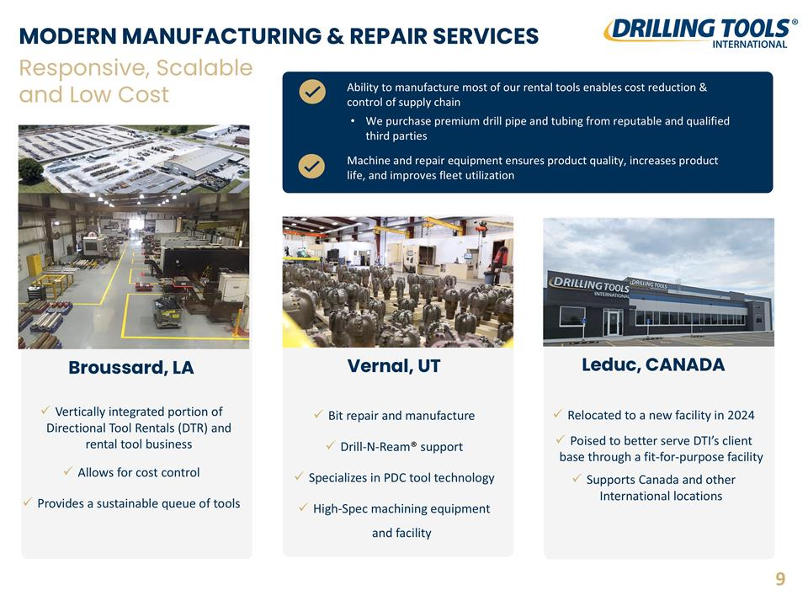
MODERN MANUFACTURING & REPAIR SERVICES Leduc, CANADA Relocated to a new facility in 2024 Poised to better serve DTI’s client base through a fit-for-purpose facility Supports Canada and other International locations Responsive, Scalable and Low Cost Vernal, UT Bit repair and manufacture Drill-N-Ream® support Specializes in PDC tool technology High-Spec machining equipment and facility Ability to manufacture most of our rental tools enables cost reduction & control of supply chain Machine and repair equipment ensures product quality, increases product life, and improves fleet utilization Broussard, LA Vertically integrated portion of Directional Tool Rentals (DTR) and rental tool business Allows for cost control Provides a sustainable queue of tools We purchase premium drill pipe and tubing from reputable and qualified third parties 9

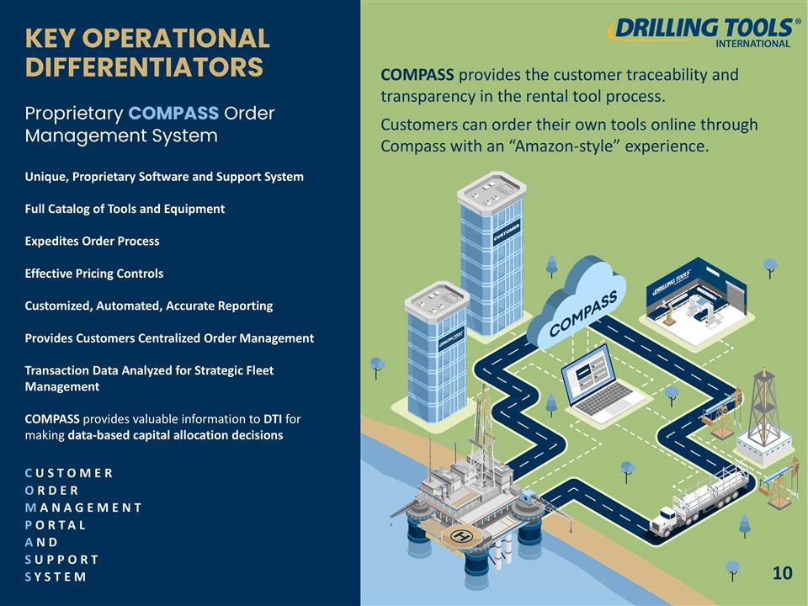
COMPASS provides the customer traceability and transparency in the rental tool process. Customers can order their own tools online through Compass with an “Amazon-style” experience. KEY OPERATIONAL DIFFERENTIATORS Proprietary COMPASS Order Management System Unique, Proprietary Software and Support System Full Catalog of Tools and Equipment Expedites Order Process Effective Pricing Controls Customized, Automated, Accurate Reporting Provides Customers Centralized Order Management Transaction Data Analyzed for Strategic Fleet Management COMPASS provides valuable information to DTI for making data-based capital allocation decisions CUSTOMER ORDER MANAGEMENT PORTAL AND SUPPORT SYSTEM 10

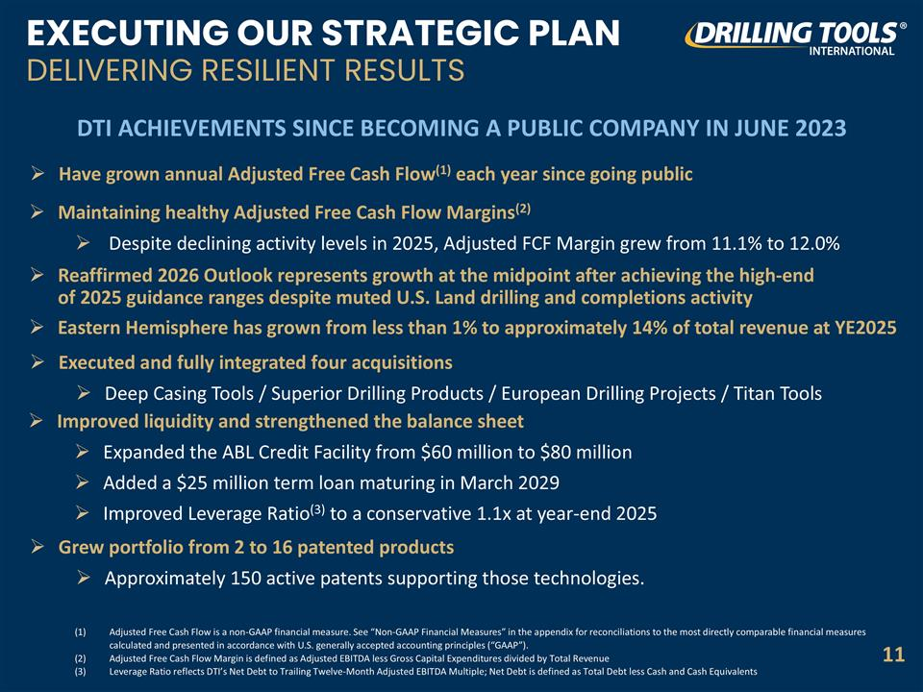
EXECUTING OUR STRATEGIC PLAN DELIVERING RESILIENT RESULTS DTI ACHIEVEMENTS SINCE BECOMING A PUBLIC COMPANY IN JUNE 2023 Executed and fully integrated four acquisitions Deep Casing Tools / Superior Drilling Products / European Drilling Projects / Titan Tools Improved liquidity and strengthened the balance sheet Expanded the ABL Credit Facility from $60 million to $80 million Added a $25 million term loan maturing in March 2029 Improved Leverage Ratio(3) to a conservative 1.1x at year-end 2025 Grew portfolio from 2 to 16 patented products Approximately 150 active patents supporting those technologies. Adjusted Free Cash Flow is a non-GAAP financial measure. See “Non-GAAP Financial Measures” in the appendix for reconciliations to the most directly comparable financial measures calculated and presented in accordance with U.S. generally accepted accounting principles (“GAAP”). Adjusted Free Cash Flow Margin is defined as Adjusted EBITDA less Gross Capital Expenditures divided by Total Revenue Leverage Ratio reflects DTI’s Net Debt to Trailing Twelve-Month Adjusted EBITDA Multiple; Net Debt is defined as Total Debt less Cash and Cash Equivalents 11 Maintaining healthy Adjusted Free Cash Flow Margins(2) Despite declining activity levels in 2025, Adjusted FCF Margin grew from 11.1% to 12.0% Have grown annual Adjusted Free Cash Flow(1) each year since going public Reaffirmed 2026 Outlook represents growth at the midpoint after achieving the high-end of 2025 guidance ranges despite muted U.S. Land drilling and completions activity Eastern Hemisphere has grown from less than 1% to approximately 14% of total revenue at YE2025

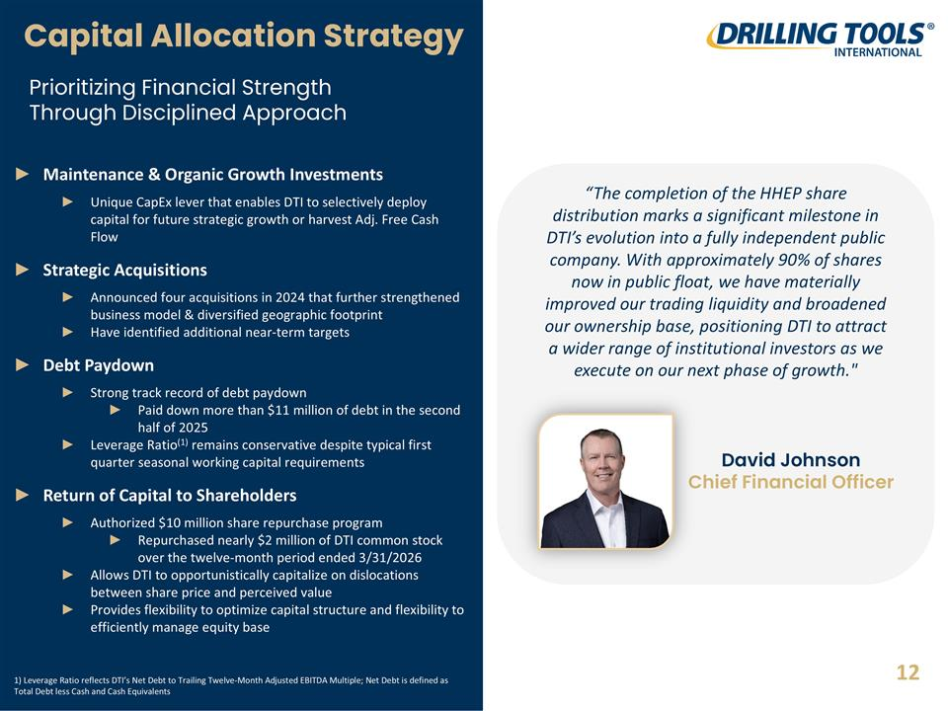
Capital Allocation Strategy Maintenance & Organic Growth Investments Unique CapEx lever that enables DTI to selectively deploy capital for future strategic growth or harvest Adj. Free Cash Flow Strategic Acquisitions Announced four acquisitions in 2024 that further strengthened business model & diversified geographic footprint Have identified additional near-term targets Debt Paydown Strong track record of debt paydown Paid down more than $11 million of debt in the second half of 2025 Leverage Ratio(1) remains conservative despite typical first quarter seasonal working capital requirements Return of Capital to Shareholders Authorized $10 million share repurchase program Repurchased nearly $2 million of DTI common stock over the twelve-month period ended 3/31/2026 Allows DTI to opportunistically capitalize on dislocations between share price and perceived value Provides flexibility to optimize capital structure and flexibility to efficiently manage equity base Prioritizing Financial Strength Through Disciplined Approach 12 “The completion of the HHEP share distribution marks a significant milestone in DTI’s evolution into a fully independent public company. With approximately 90% of shares now in public float, we have materially improved our trading liquidity and broadened our ownership base, positioning DTI to attract a wider range of institutional investors as we execute on our next phase of growth." David Johnson Chief Financial Officer 1) Leverage Ratio reflects DTI’s Net Debt to Trailing Twelve-Month Adjusted EBITDA Multiple; Net Debt is defined as Total Debt less Cash and Cash Equivalents

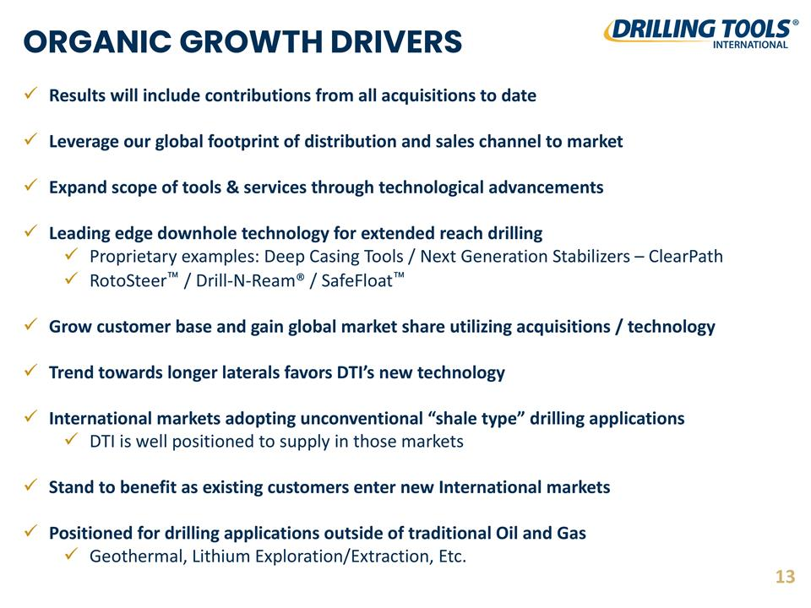
ORGANIC GROWTH DRIVERS Results will include contributions from all acquisitions to date Leverage our global footprint of distribution and sales channel to market Expand scope of tools & services through technological advancements Leading edge downhole technology for extended reach drilling Proprietary examples: Deep Casing Tools / Next Generation Stabilizers – ClearPath RotoSteer™ / Drill-N-Ream® / SafeFloat™ Grow customer base and gain global market share utilizing acquisitions / technology Trend towards longer laterals favors DTI’s new technology International markets adopting unconventional “shale type” drilling applications DTI is well positioned to supply in those markets Stand to benefit as existing customers enter new International markets Positioned for drilling applications outside of traditional Oil and Gas Geothermal, Lithium Exploration/Extraction, Etc. 13

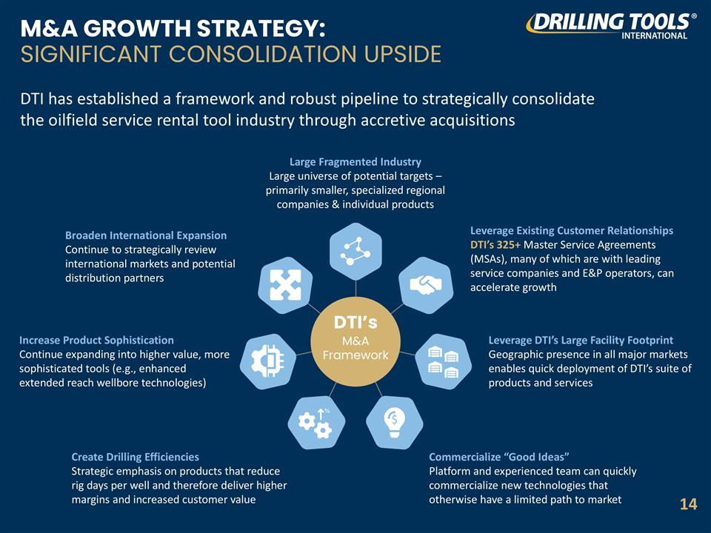
M&A GROWTH STRATEGY: SIGNIFICANT CONSOLIDATION UPSIDE DTI has established a framework and robust pipeline to strategically consolidate the oilfield service rental tool industry through accretive acquisitions Large Fragmented Industry Large universe of potential targets – primarily smaller, specialized regional companies & individual products Leverage Existing Customer Relationships DTI’s 325+ Master Service Agreements (MSAs), many of which are with leading service companies and E&P operators, can accelerate growth Leverage DTI’s Large Facility Footprint Geographic presence in all major markets enables quick deployment of DTI’s suite of products and services Commercialize “Good Ideas” Platform and experienced team can quickly commercialize new technologies that otherwise have a limited path to market Create Drilling Efficiencies Strategic emphasis on products that reduce rig days per well and therefore deliver higher margins and increased customer value Increase Product Sophistication Continue expanding into higher value, more sophisticated tools (e.g., enhanced extended reach wellbore technologies) Broaden International Expansion Continue to strategically review international markets and potential distribution partners DTI’s M&A Framework 14

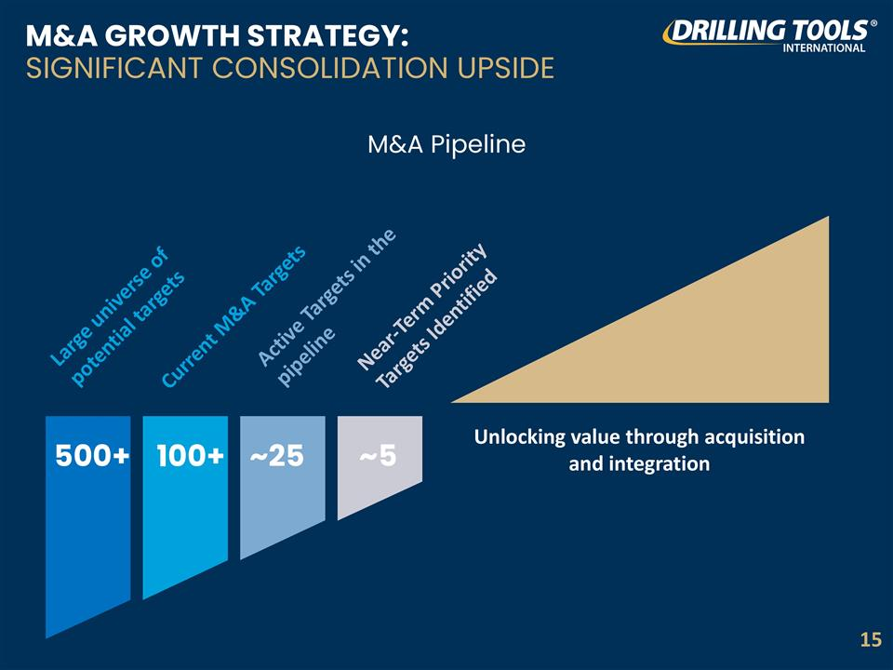
M&A GROWTH STRATEGY: SIGNIFICANT CONSOLIDATION UPSIDE M&A Pipeline Large universe of potential targets Current M&A Targets Active Targets in the pipeline Near-Term Priority Targets Identified 500+ 100+ ~25 ~5 Unlocking value through acquisition and integration 15

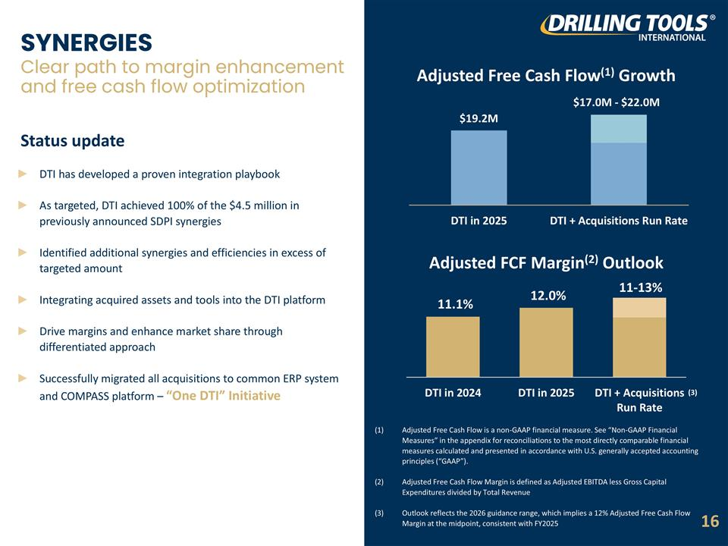
SYNERGIES Clear path to margin enhancement and free cash flow optimization Adjusted Free Cash Flow(1) Growth Adjusted FCF Margin(2) Outlook Adjusted Free Cash Flow is a non-GAAP financial measure. See “Non-GAAP Financial Measures” in the appendix for reconciliations to the most directly comparable financial measures calculated and presented in accordance with U.S. generally accepted accounting principles (“GAAP”). Adjusted Free Cash Flow Margin is defined as Adjusted EBITDA less Gross Capital Expenditures divided by Total Revenue Outlook reflects the 2026 guidance range, which implies a 12% Adjusted Free Cash Flow Margin at the midpoint, consistent with FY2025 DTI has developed a proven integration playbook As targeted, DTI achieved 100% of the $4.5 million in previously announced SDPI synergies Identified additional synergies and efficiencies in excess of targeted amount Integrating acquired assets and tools into the DTI platform Drive margins and enhance market share through differentiated approach Successfully migrated all acquisitions to common ERP system and COMPASS platform – “One DTI” Initiative Status update $19.2M $17.0M - $22.0M (3) 16 11.1% 12.0% 11-13%

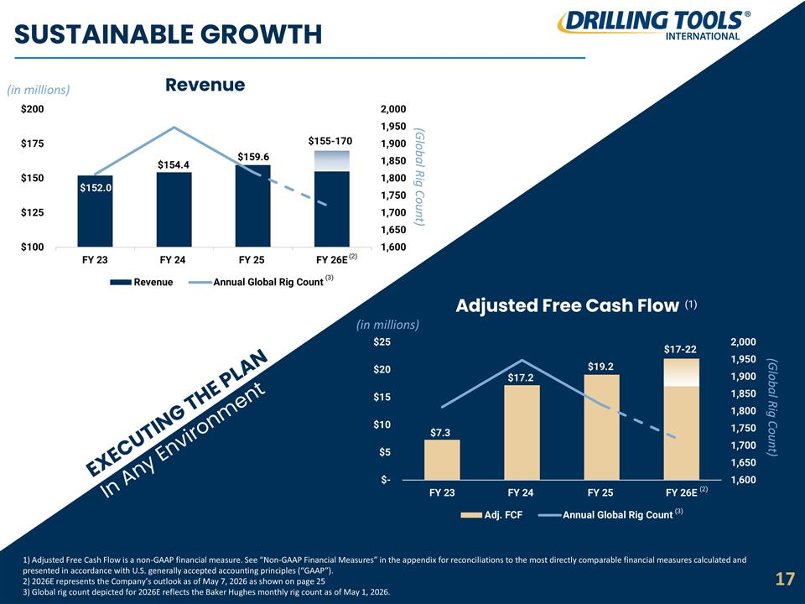
1) Adjusted Free Cash Flow is a non-GAAP financial measure. See “Non-GAAP Financial Measures” in the appendix for reconciliations to the most directly comparable financial measures calculated and presented in accordance with U.S. generally accepted accounting principles (“GAAP”). 2) 2026E represents the Company’s outlook as of May 7, 2026 as shown on page 25 3) Global rig count depicted for 2026E reflects the Baker Hughes monthly rig count as of May 1, 2026. SUSTAINABLE GROWTH (in millions) Revenue $152.0 (2) 17 Adjusted Free Cash Flow EXECUTING THE PLAN In Any Environment (in millions) (3) $154.4 $159.6 $155-170 (1) (Global Rig Count) (Global Rig Count) (3) $7.3 $17.2 $19.2 $17-22 (2)

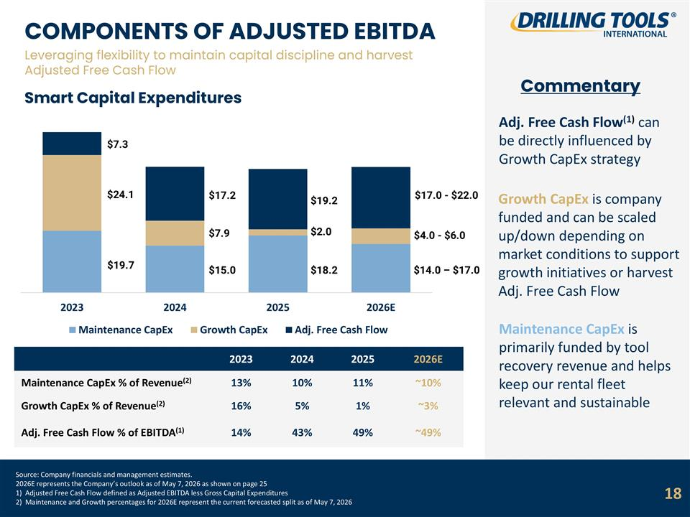
Source: Company financials and management estimates. 2026E represents the Company’s outlook as of May 7, 2026 as shown on page 25 1) Adjusted Free Cash Flow defined as Adjusted EBITDA less Gross Capital Expenditures 2) Maintenance and Growth percentages for 2026E represent the current forecasted split as of May 7, 2026 COMPONENTS OF ADJUSTED EBITDA Leveraging flexibility to maintain capital discipline and harvest Adjusted Free Cash Flow Smart Capital Expenditures Commentary 2023 2024 2025 2026E Maintenance CapEx % of Revenue(2) 13% 10% 11% ~10% Growth CapEx % of Revenue(2) 16% 5% 1% ~3% Adj. Free Cash Flow % of EBITDA(1) 14% 43% 49% ~49% Adj. Free Cash Flow(1) can be directly influenced by Growth CapEx strategy Growth CapEx is company funded and can be scaled up/down depending on market conditions to support growth initiatives or harvest Adj. Free Cash Flow Maintenance CapEx is primarily funded by tool recovery revenue and helps keep our rental fleet relevant and sustainable $17.2 $7.9 $15.0 $19.2 $2.0 $18.2 $17.0 - $22.0 $4.0 - $6.0 $14.0 – $17.0 18 $7.3 $24.1 $19.7

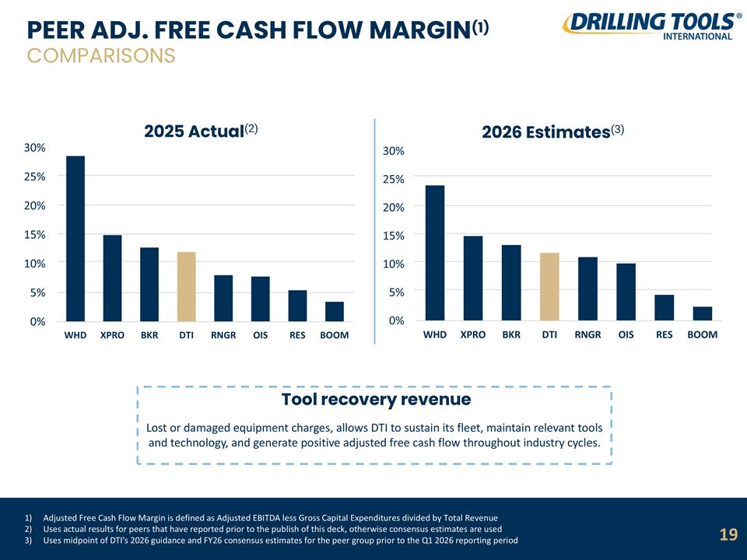
Adjusted Free Cash Flow Margin is defined as Adjusted EBITDA less Gross Capital Expenditures divided by Total Revenue Uses actual results for peers that have reported prior to the publish of this deck, otherwise consensus estimates are used Uses midpoint of DTI's 2026 guidance and FY26 consensus estimates for the peer group prior to the Q1 2026 reporting period PEER ADJ. FREE CASH FLOW MARGIN(1) COMPARISONS 2025 Actual(2) Tool recovery revenue Lost or damaged equipment charges, allows DTI to sustain its fleet, maintain relevant tools and technology, and generate positive adjusted free cash flow throughout industry cycles. 2026 Estimates(3) 19

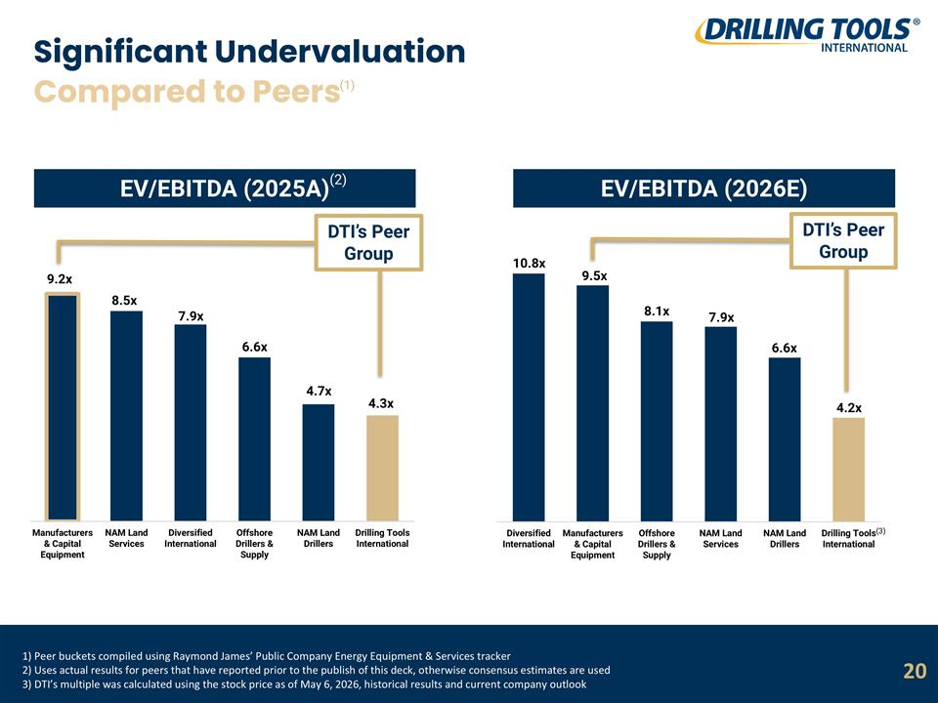
1) Peer buckets compiled using Raymond James’ Public Company Energy Equipment & Services tracker 2) Uses actual results for peers that have reported prior to the publish of this deck, otherwise consensus estimates are used 3) DTI’s multiple was calculated using the stock price as of May 6, 2026, historical results and current company outlook Significant Undervaluation EV/EBITDA (2025A) 20 EV/EBITDA (2026E) 9.2x 8.5x 7.9x 6.6x 4.7x 4.3x 10.8x 9.5x 8.1x 7.9x 6.6x 4.2x Compared to Peers DTI’s Peer Group DTI’s Peer Group (2) (3) (1)

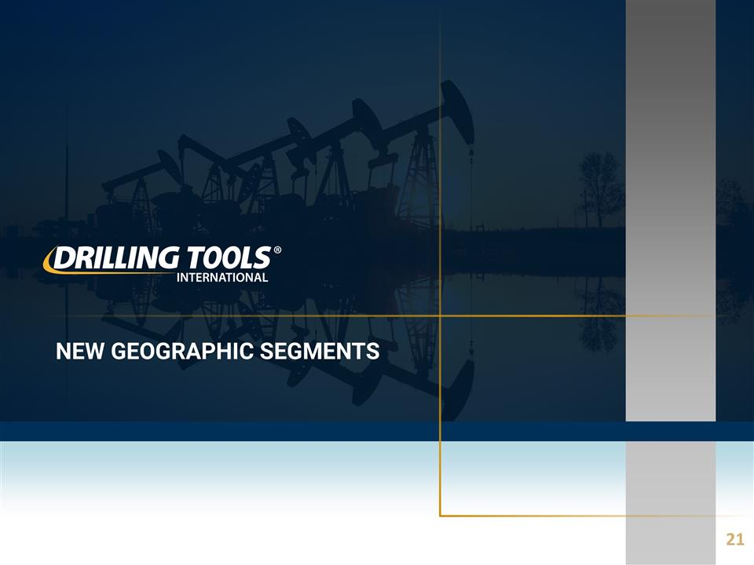
NEW GEOGRAPHIC SEGMENTS 21

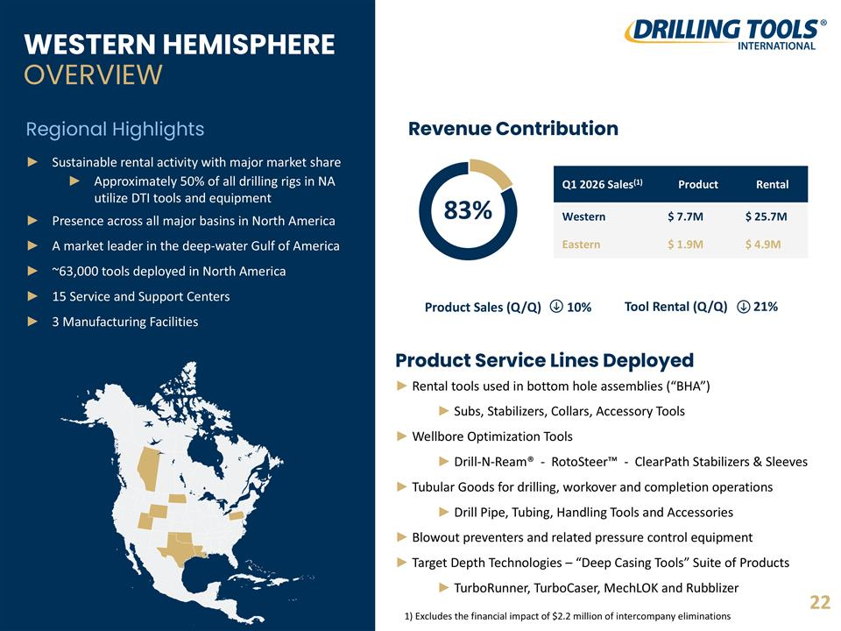
Tool Rental (Q/Q) 21% WESTERN HEMISPHERE OVERVIEW Sustainable rental activity with major market share Approximately 50% of all drilling rigs in NA utilize DTI tools and equipment Presence across all major basins in North America A market leader in the deep-water Gulf of America ~63,000 tools deployed in North America 15 Service and Support Centers 3 Manufacturing Facilities Regional Highlights Revenue Contribution Q1 2026 Sales(1) Product Rental Western $ 7.7M $ 25.7M Eastern $ 1.9M $ 4.9M 83% Product Service Lines Deployed Rental tools used in bottom hole assemblies (“BHA”) Subs, Stabilizers, Collars, Accessory Tools Wellbore Optimization Tools Drill-N-Ream® - RotoSteer™ - ClearPath Stabilizers & Sleeves Tubular Goods for drilling, workover and completion operations Drill Pipe, Tubing, Handling Tools and Accessories Blowout preventers and related pressure control equipment Target Depth Technologies – “Deep Casing Tools” Suite of Products TurboRunner, TurboCaser, MechLOK and Rubblizer 1) Excludes the financial impact of $2.2 million of intercompany eliminations 22 Product Sales (Q/Q) 10%

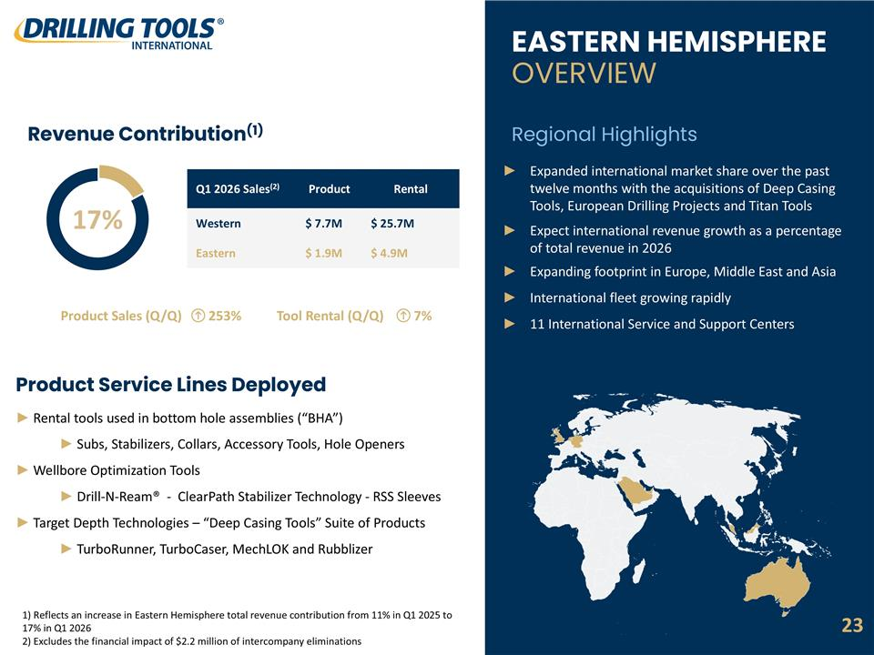
Tool Rental (Q/Q) 7% Product Sales (Q/Q) 253% Revenue Contribution(1) Q1 2026 Sales(2) Product Rental Western $ 7.7M $ 25.7M Eastern $ 1.9M $ 4.9M 17% Product Service Lines Deployed Rental tools used in bottom hole assemblies (“BHA”) Subs, Stabilizers, Collars, Accessory Tools, Hole Openers Wellbore Optimization Tools Drill-N-Ream® - ClearPath Stabilizer Technology - RSS Sleeves Target Depth Technologies – “Deep Casing Tools” Suite of Products TurboRunner, TurboCaser, MechLOK and Rubblizer EASTERN HEMISPHERE OVERVIEW Expanded international market share over the past twelve months with the acquisitions of Deep Casing Tools, European Drilling Projects and Titan Tools Expect international revenue growth as a percentage of total revenue in 2026 Expanding footprint in Europe, Middle East and Asia International fleet growing rapidly 11 International Service and Support Centers Regional Highlights 1) Reflects an increase in Eastern Hemisphere total revenue contribution from 11% in Q1 2025 to 17% in Q1 2026 2) Excludes the financial impact of $2.2 million of intercompany eliminations Tubular Goods for drilling, workover and completion operations Drill Pipe, Tubing, Handling Tools and Accessories Blowout preventers and related pressure control equipment 23

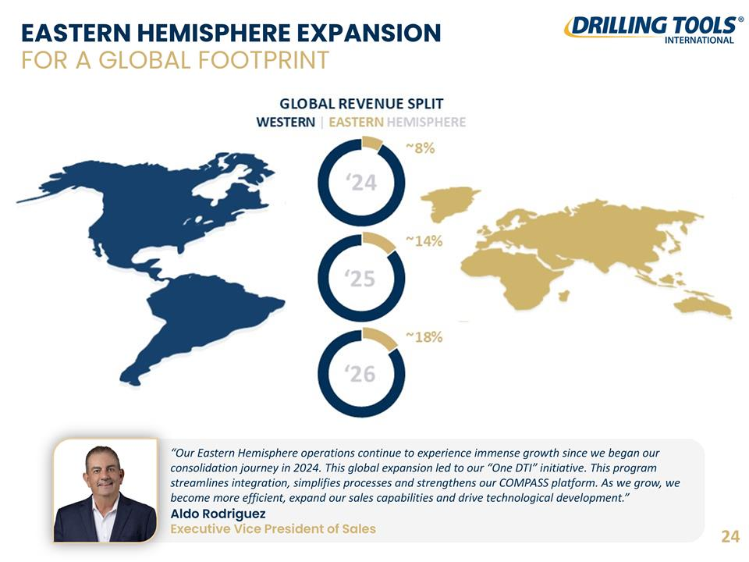
EASTERN HEMISPHERE EXPANSION FOR A GLOBAL FOOTPRINT “Our Eastern Hemisphere operations continue to experience immense growth since we began our consolidation journey in 2024. This global expansion led to our “One DTI” initiative. This program streamlines integration, simplifies processes and strengthens our COMPASS platform. As we grow, we become more efficient, expand our sales capabilities and drive technological development.” Aldo Rodriguez Executive Vice President of Sales 24

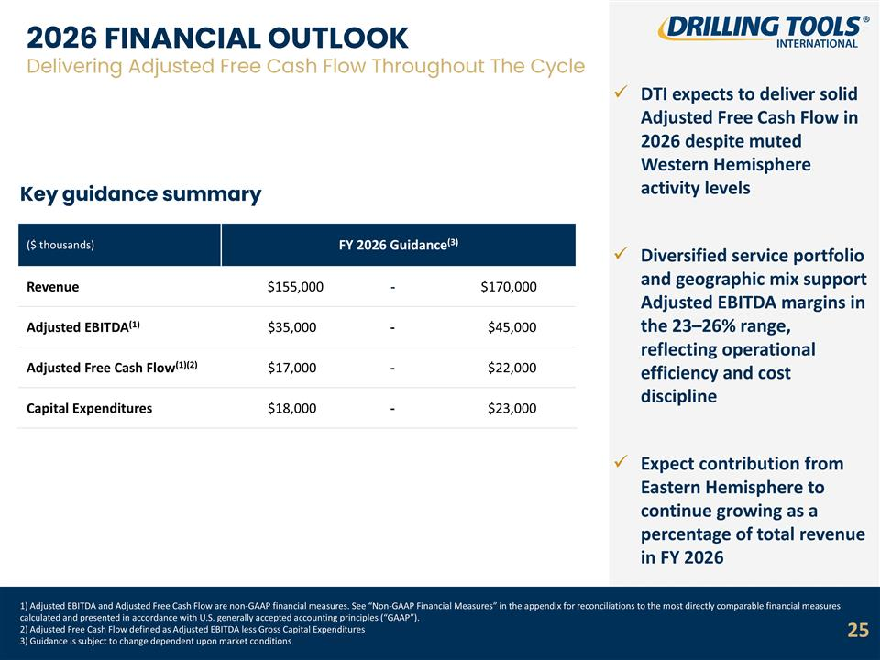
1) Adjusted EBITDA and Adjusted Free Cash Flow are non-GAAP financial measures. See “Non-GAAP Financial Measures” in the appendix for reconciliations to the most directly comparable financial measures calculated and presented in accordance with U.S. generally accepted accounting principles (“GAAP”). 2) Adjusted Free Cash Flow defined as Adjusted EBITDA less Gross Capital Expenditures 3) Guidance is subject to change dependent upon market conditions 2026 FINANCIAL OUTLOOK Delivering Adjusted Free Cash Flow Throughout The Cycle Key guidance summary DTI expects to deliver solid Adjusted Free Cash Flow in 2026 despite muted Western Hemisphere activity levels Diversified service portfolio and geographic mix support Adjusted EBITDA margins in the 23–26% range, reflecting operational efficiency and cost discipline Expect contribution from Eastern Hemisphere to continue growing as a percentage of total revenue in FY 2026 ($ thousands) FY 2026 Guidance(3) Revenue $155,000 - $170,000 Adjusted EBITDA(1) $35,000 - $45,000 Adjusted Free Cash Flow(1)(2) $17,000 - $22,000 Capital Expenditures $18,000 - $23,000 25

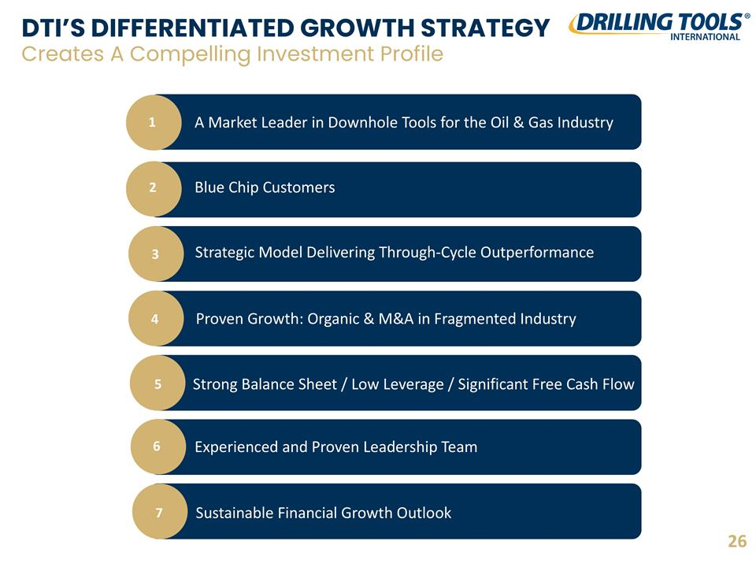
DTI’S DIFFERENTIATED GROWTH STRATEGY Creates A Compelling Investment Profile 1 A Market Leader in Downhole Tools for the Oil & Gas Industry 2 Blue Chip Customers 3 Strategic Model Delivering Through-Cycle Outperformance 4 Proven Growth: Organic & M&A in Fragmented Industry 5 Strong Balance Sheet / Low Leverage / Significant Free Cash Flow 6 Experienced and Proven Leadership Team 7 Sustainable Financial Growth Outlook 26

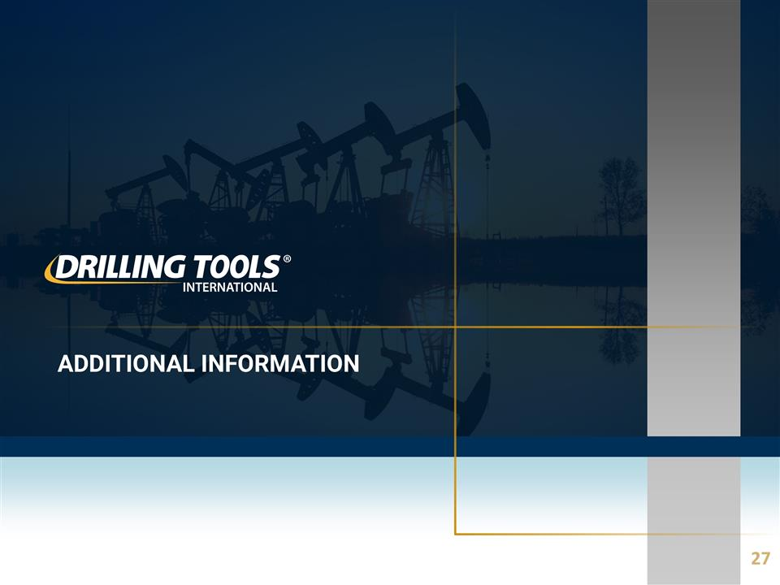
Additional Information 27

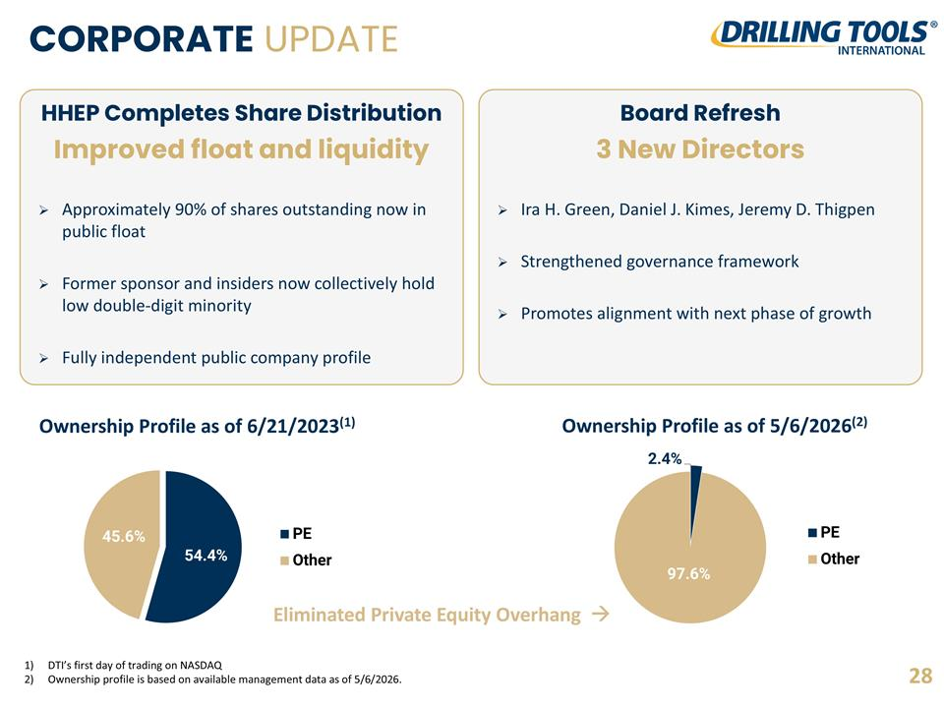
ORGANIZATIONAL STRUCTURE CORPORATE UPDATE Ownership Profile as of 6/21/2023(1) Ownership Profile as of 5/6/2026(2) Eliminated Private Equity Overhang à 28 DTI’s first day of trading on NASDAQ Ownership profile is based on available management data as of 5/6/2026. HHEP Completes Share Distribution Improved float and liquidity Approximately 90% of shares outstanding now in public float Former sponsor and insiders now collectively hold low double-digit minority Fully independent public company profile Board Refresh 3 New Directors Ira H. Green, Daniel J. Kimes, Jeremy D. Thigpen Strengthened governance framework Promotes alignment with next phase of growth

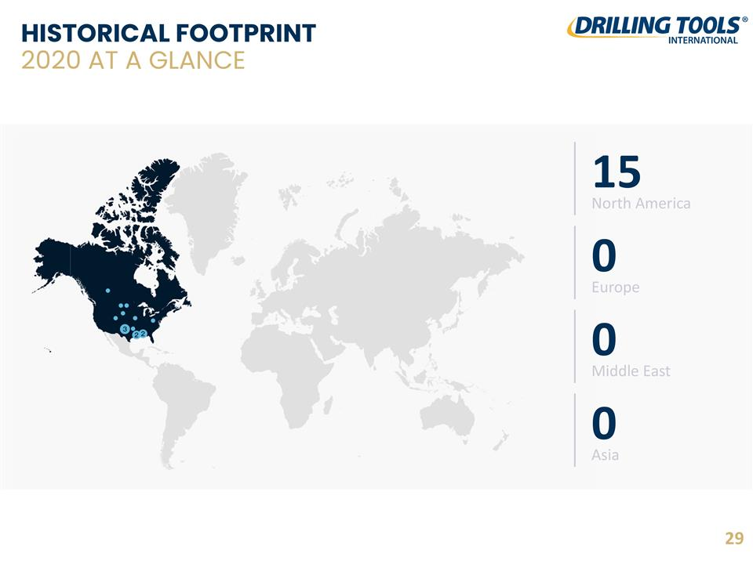
HISTORICAL FOOTPRINT 2020 AT A GLANCE 29 15 North America 0 Europe 0 Middle East 0 Asia

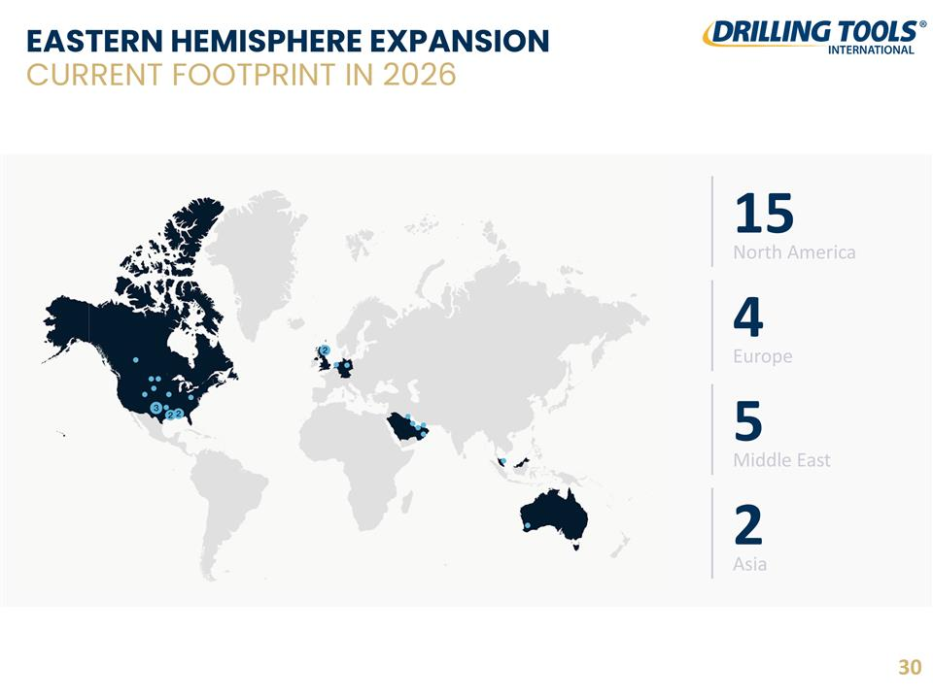
EASTERN HEMISPHERE EXPANSION CURRENT FOOTPRINT IN 2026 30 15 North America 4 Europe 5 Middle East 2 Asia

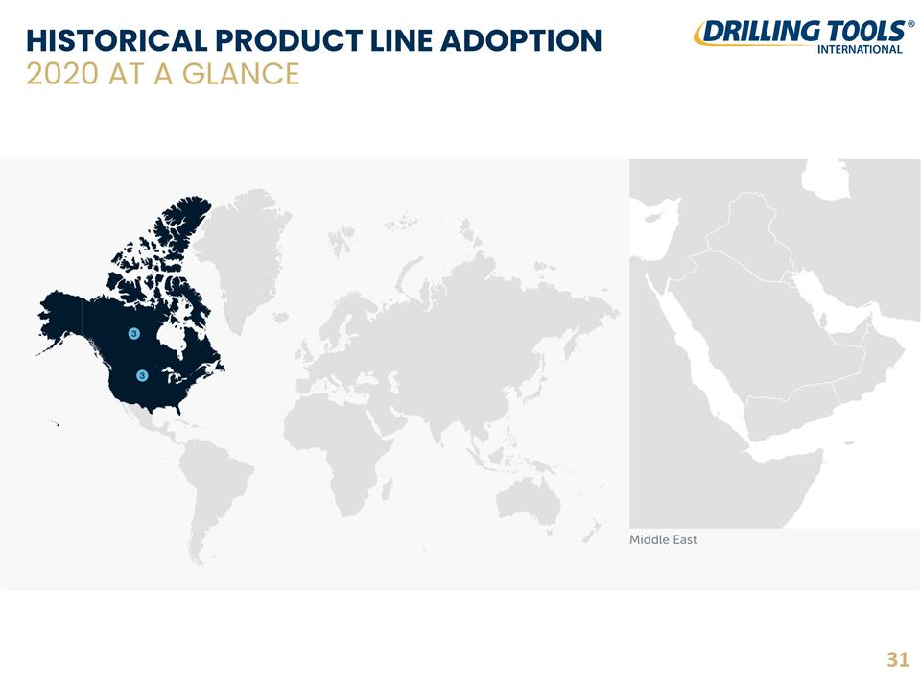
HISTORICAL PRODUCT LINE ADOPTION 2020 AT A GLANCE 31

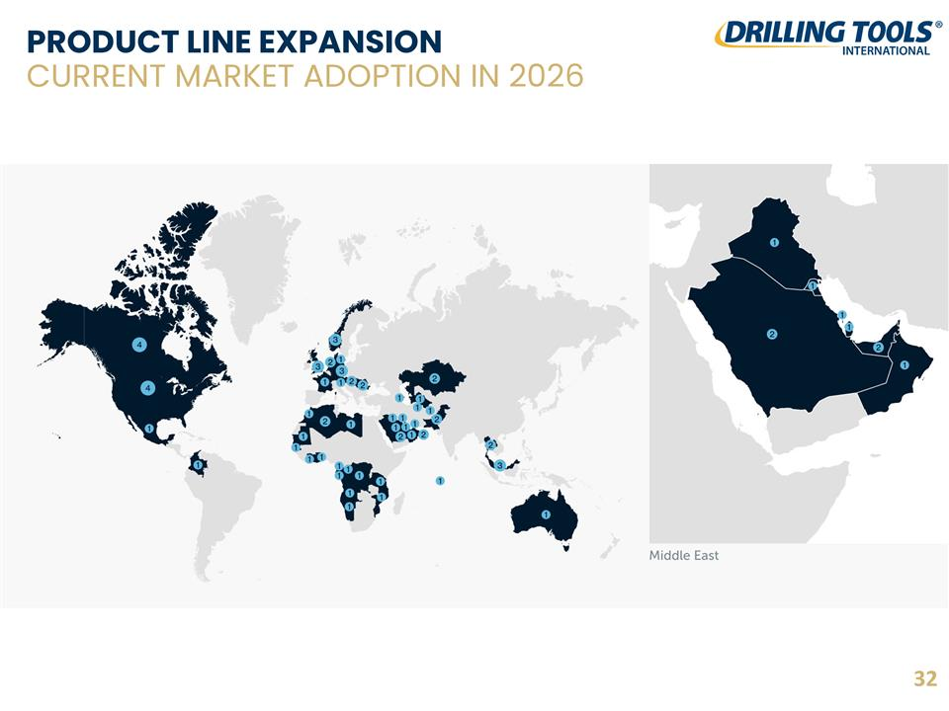
PRODUCT LINE EXPANSION CURRENT MARKET ADOPTION IN 2026 32

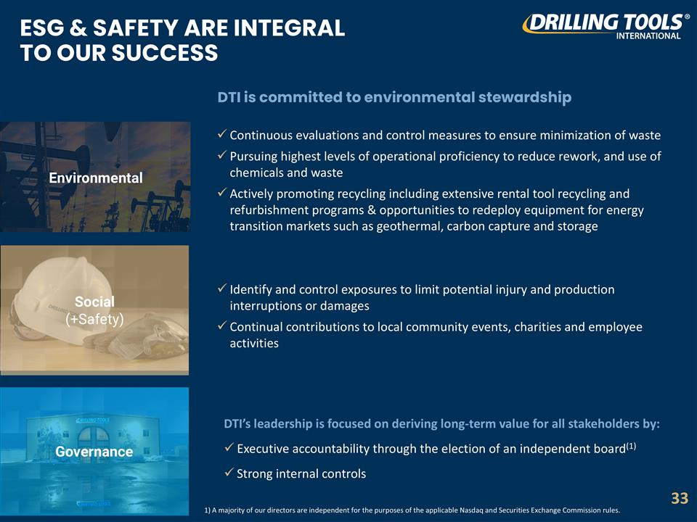
Governance Social (+Safety) Continuous evaluations and control measures to ensure minimization of waste Pursuing highest levels of operational proficiency to reduce rework, and use of chemicals and waste Actively promoting recycling including extensive rental tool recycling and refurbishment programs & opportunities to redeploy equipment for energy transition markets such as geothermal, carbon capture and storage DTI is committed to environmental stewardship ESG & SAFETY ARE INTEGRAL TO OUR SUCCESS Environmental Identify and control exposures to limit potential injury and production interruptions or damages Continual contributions to local community events, charities and employee activities DTI’s leadership is focused on deriving long-term value for all stakeholders by: Executive accountability through the election of an independent board(1) Strong internal controls 33 1) A majority of our directors are independent for the purposes of the applicable Nasdaq and Securities Exchange Commission rules.

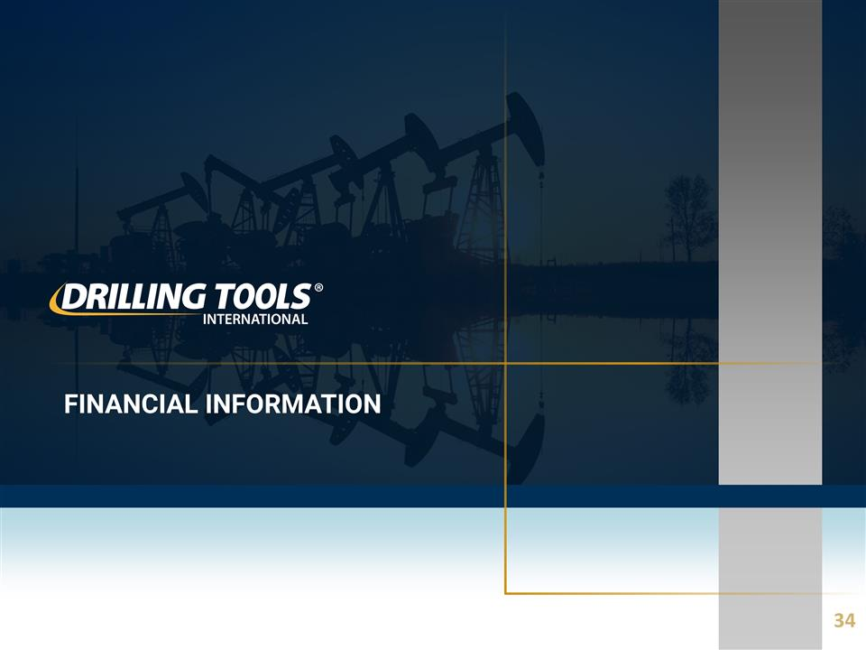
Financial information 34

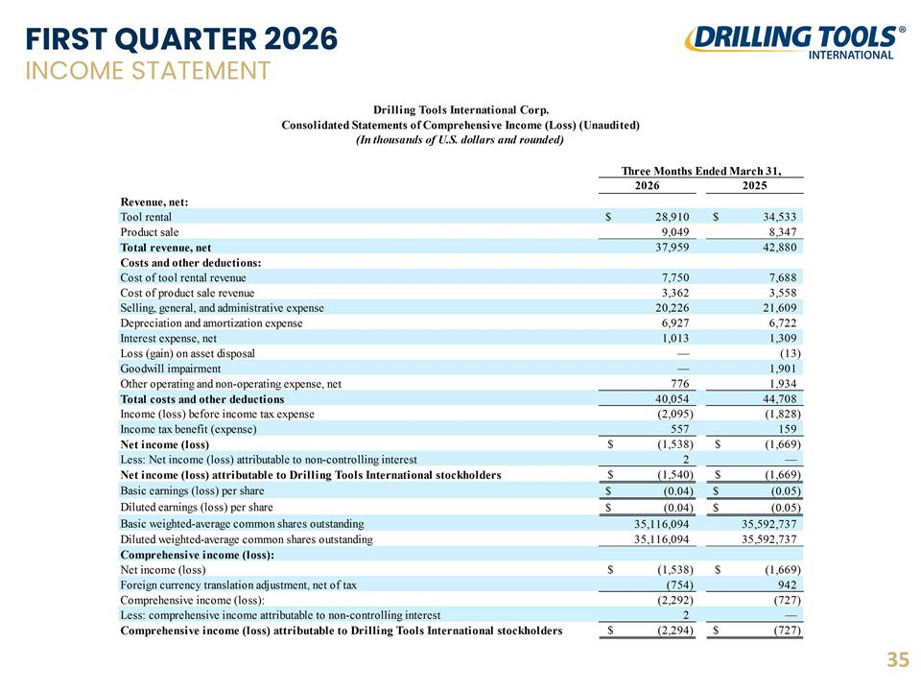
FIRST QUARTER 2026 INCOME STATEMENT 35

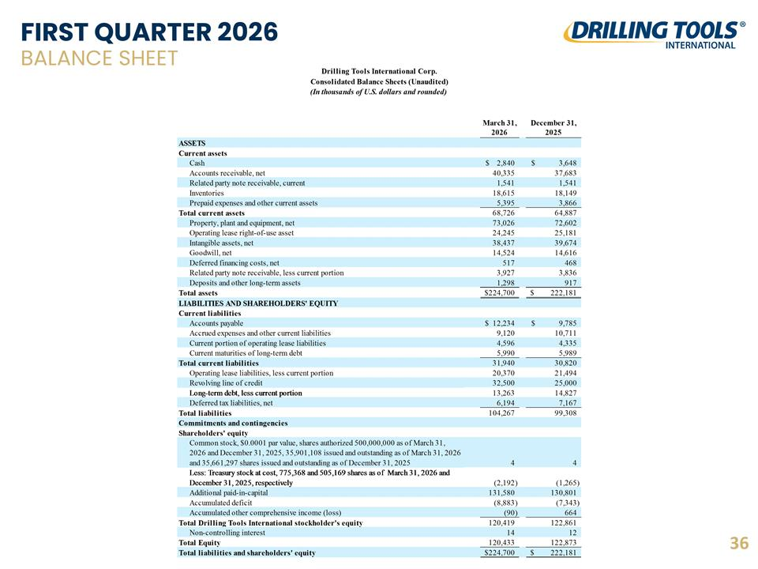
FIRST QUARTER 2026 BALANCE SHEET 36

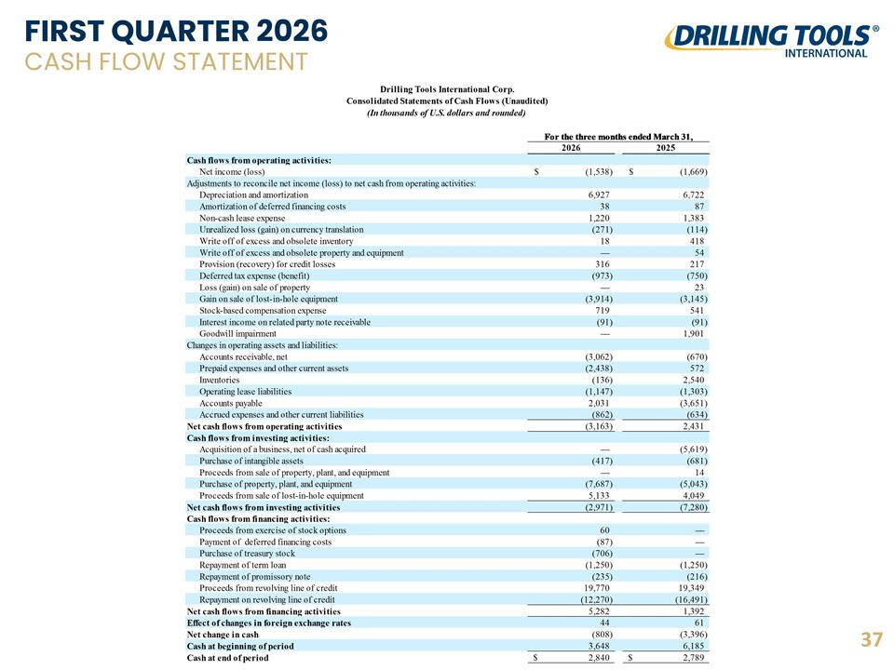
FIRST QUARTER 2026 CASH FLOW STATEMENT 37

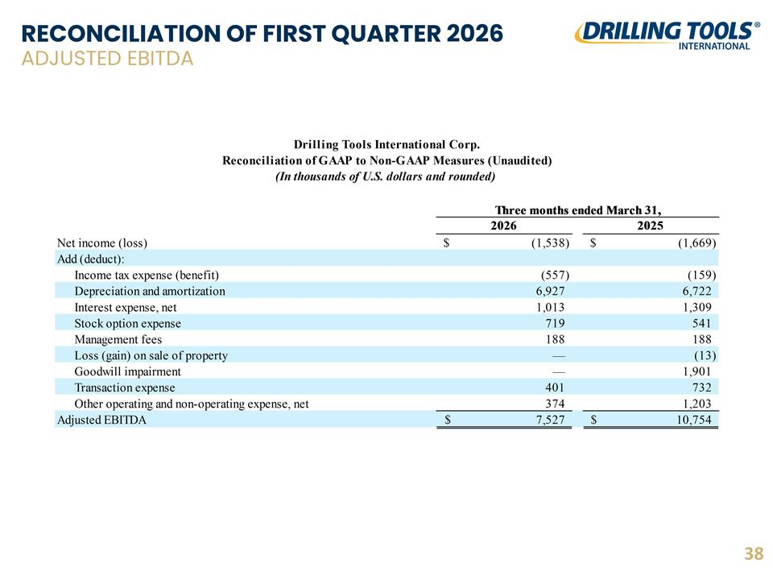
RECONCILIATION OF FIRST QUARTER 2026 ADJUSTED EBITDA 38

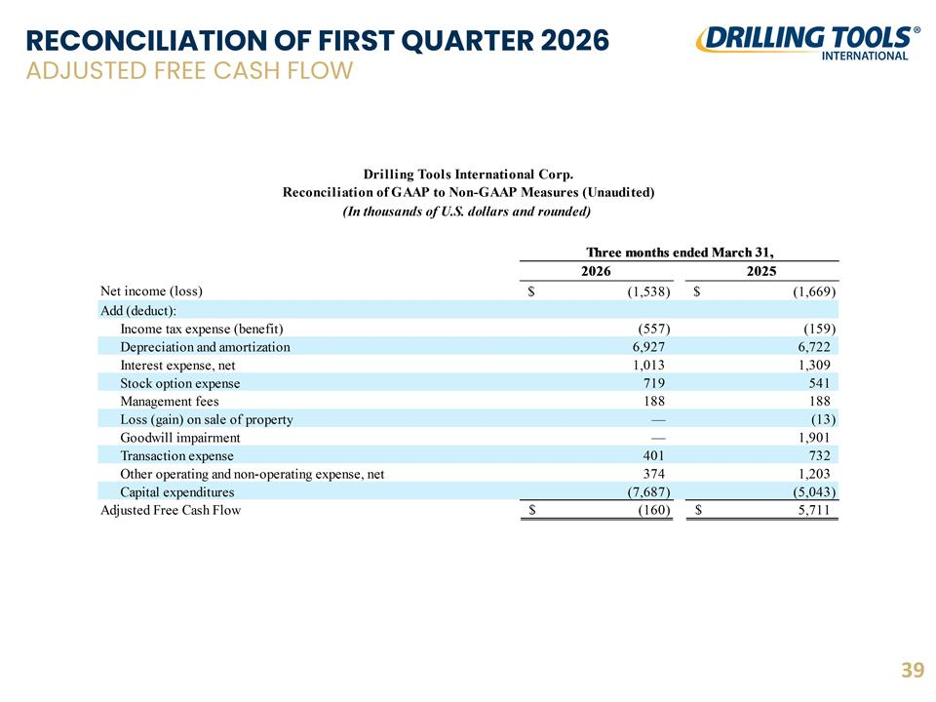
RECONCILIATION OF FIRST QUARTER 2026 ADJUSTED FREE CASH FLOW 39

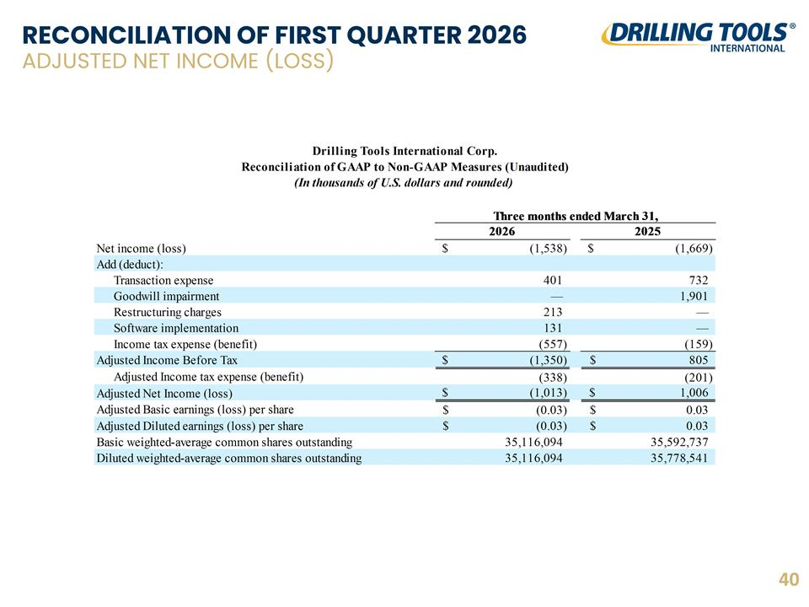
RECONCILIATION OF FIRST QUARTER 2026 ADJUSTED NET INCOME (LOSS) 40

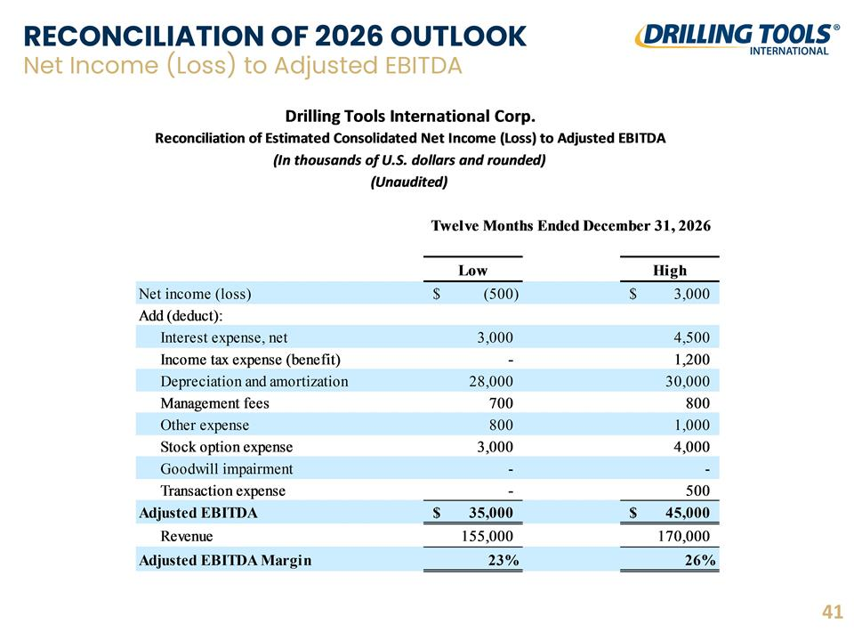
RECONCILIATION OF 2026 OUTLOOK Net Income (Loss) to Adjusted EBITDA 41

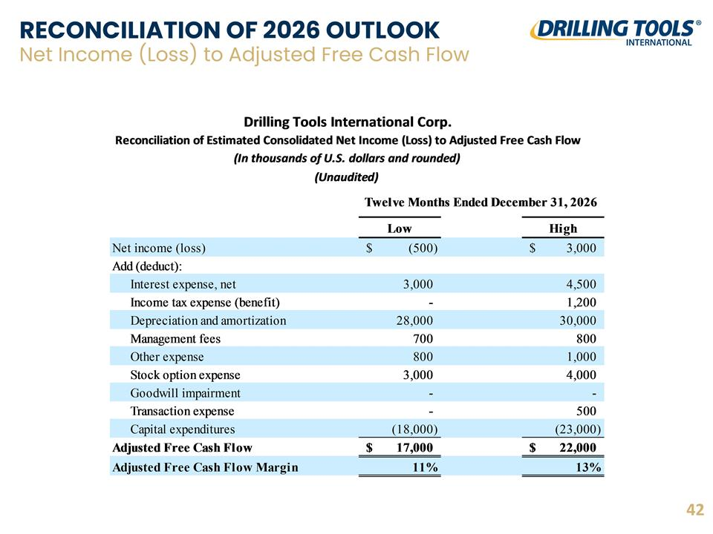
RECONCILIATION OF 2026 OUTLOOK Net Income (Loss) to Adjusted Free Cash Flow 42

